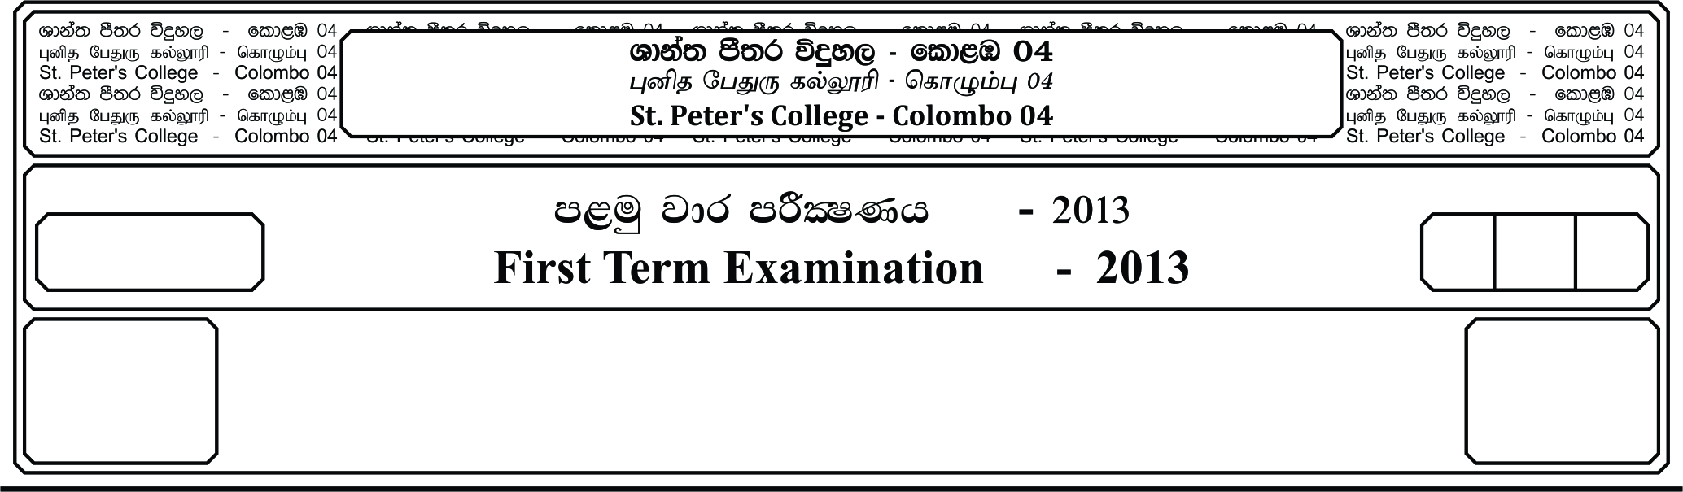

13 fY%aKsh

GRADE 13

E

meh 01

Hour 01

I

**f;jk jdr mÍCIKh - 2021**

**Third Term Examination - 2021**

idudkH bx.%Sis - »

**GENERAL ENGLISH – I**

**Part - A**

**01. Fill the blanks with correct prepositions given in the list. (Marks 10)**

by , on , from , with , in , at , against , to , for

1. Tell the man that we can’t repair his bicycle ____________ once as the spores will not be delivered on Tuesday.

2. We felt very sorry ____________ Sylvia who hadn’t been given any prize.

3. We were forced to work ____________ the clock because our manager wanted this plan to be ready by the following day.

4. The robbers had escaped ____________ the bank before the police arrived.

5. The bill hasn’t been accepted by the governmen, ____________ other words, our salries won’t be higher.

6. Are you going to send this package ____________ mail?

7. “Will you show us your new residence, please?” “Ok. I will do it ____________ great pleasure.”

8. I prefer this shirt ____________ the one you were wearing yesterday.

9. The customer was ____________ time for the meeting.

10. Our company is ashamed ____________ him.

**02. Fill the blanks with the correct from of the verb in bracket.** **(Marks 10)**

Mark **(1).** ____________ ***(live)*** in USA and **(2).** ____________ ***(decide)*** to return to the country where he **(3).** ____________ ***(born)***. He **(4).** ____________ ***(write)*** several lists to make sure he **(5).** ____________ ***(not forget)*** anything. By the time he **(6).** ____________ ***(be)*** ready to start packing he had several lists. One with the things that he definitely **(7).** ____________ ***(take)*** with her, one with “in case there **(8).** ____________ ***(be)*** Space left” and third with “in case there **(9).** ____________ ***(be)***” still space left.” **(10).** ____________ ***(make)*** it into the five suitcases he will carry with him.

**03. Complete the sentences with the correct form of the words in brackets.**

**(Marks 10)**

1. Two thirds of the ___________ of this company are engineers. ***(employ)***

2. Could we have a minute of ___________ ***(silent)***

3. I was ___________ and unhappy ***(misery)***

4. She doesn’t live in my ___________ ***(neighbour)***

5. I have the best and most ___________ intentions ***(honour)***

6. She is very ___________ to her grandmother ***(attend)***

7. All the wealth in the world is ___________ when you’re dead ***(worth)***

8. Do you trust my ___________ ***(judge)***

9. The ___________ of this ship is 30 meters ***(long)***

10. He easily learned the ___________ rules of the game ***(base)***

**04.** **Fill the blacks with the correct conjunctional words give below.** **(Marks 05)**

(therefore , uncles , althought , either-or , whenever)

1. He didn’t playing football ___________ basketball.

2. ___________ they have lot of money, They are still not happy.

3. ___________ my aunty comes to us, she brings some good gifts for the family.

4. He went out last night without her mother’s permission, ___________ he spent the whole night out side the house.

5. ___________ he finishes his homework, he can’t go out.

**05.** **Read the paragraph and answer the questions given below. (Marks 10)**

*I can’t stand smoking*

The most difficult thing for me is to sit in a place that is full of the smell of cigarettes. When you visit an internet café; the first thing you face is this big, cloud of smoke and the unplesent smell of cigerettes. It’s completely not healthy to stay in such place. Many people suffer from public places full of smokers who fill the air with their smoke. Even those who used to smoke once they stay away from this bad habit. They start feeling uncomfortable around smokers.

Nowadays people smoke everywhere, in the restaurant, offices, streets, parks, even in the hall of the hospitals. Smokers who used to smoke one pack daily and stopped can feel how much they lost of their lungs capacity. But people don’t think abour that when they smoke as young powerful strong and healthy adults.

1. What is the article talking about?

2. Can you suggest another title for this article? What is it?

3. What do the people suffer from when they smoke according to the article?

4. What other health problems do you know about smoking?

5. What do you think the reason of smoking?

06. Write a paragraph in 75-100 words starting from the following sentence. **(Marks 15)**

Many things have changed as a result of Covid 19